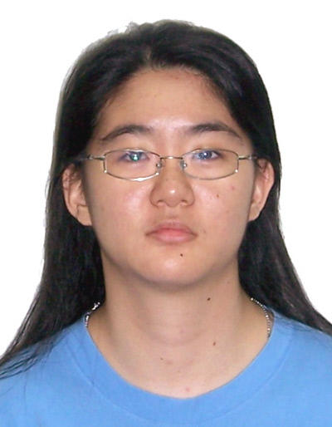
Lee JiaYing
669C Jurong West Street 64
#15-70
Singapore 643669
+65 91518078
ljy.jyl@gmail.com

Working Experience
Steven Tan Russell Bedford PAC Feb 2014 – Present
Senior Audit Associate
- Lead audit engagements, perform tax computations
- Finalise report

Paul Wan & Co Oct 2012 – Jan 2014
Assurance Associate
- Review of Internal controls; examine and analysis of P&L & BS; perform statutory audit
- Assist in preparing report

A&I Commercial Management Jul 2010 – Dec 2010
Accounts Executive
- Enter documents into general ledger; claim GST; bank reconciliation; calculation of CPF; salary listings for clients; P&L and Balance Sheet reports.

Professional Qualifications
ACCA Member 2015 ISCA Associate 2013

Academic Qualifications
University of London External System (UOL) Sep 2007 – Sep 2010
London School of Economics and Political Science (LSE)
Bachelor of Science in Accounting and Finance (Honours)
3rd Class

Innova Junior College 2005-2006
‘A’ Levels

Co-curricular Activities
Treasurer, JC Japanese Cultural Society (2005-2006)
- In charge of collecting funds from members, collecting receipts of expenses and presenting summary of club funds to teacher-in-charge when needed.
- Assistant Chairperson and Treasurer for Fund-Raising Committee; in charge of Accounts Department – setting budget and target for each individual department.
- Leader of 8-member team to participate in MANGAKA 2005; it was hard to accommodate everybody’s different timetable to meet up, last minute coordinated team to prepare for the competition and won the Best Book Prize.
- Led an 8-member team to join Hinokio Sequel Storyboard Competition.

Skills
- MS Office, Accpac 6.1, ProSystem fx Engagement, Audit Express

Languages
- English
- Mandarin

Current salary: $3,100
Expected salary: $3,700 (Negotiable)

